**COVID-19 VISUALIZATIONS**

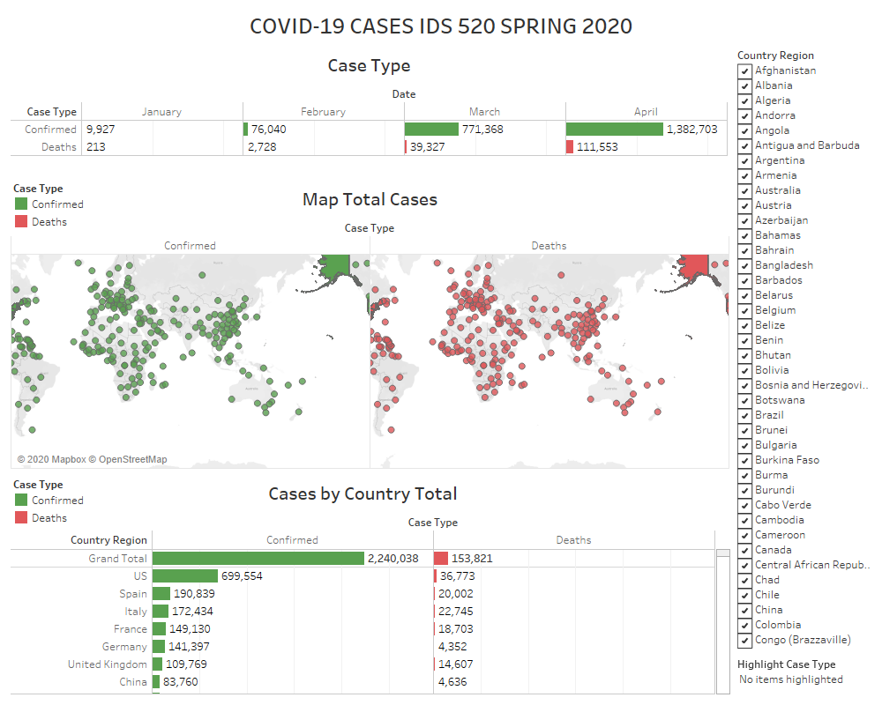

**Filtering by Country**

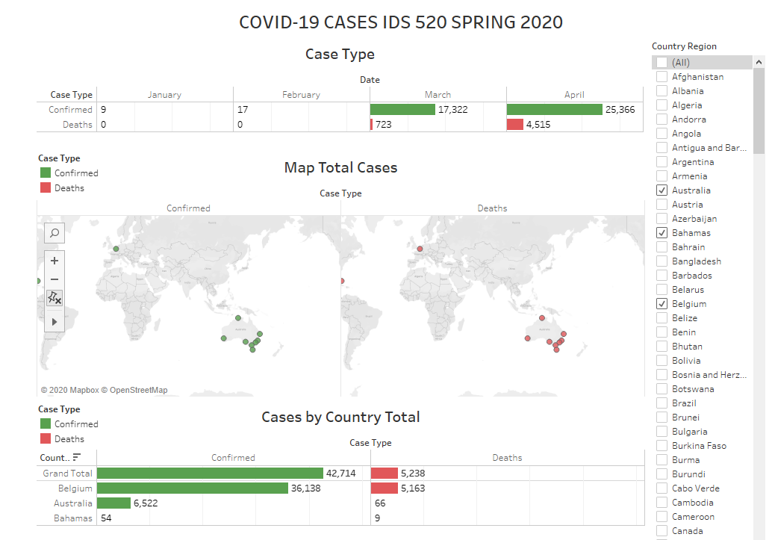

**Highlighting case type**

Confirmed case type:

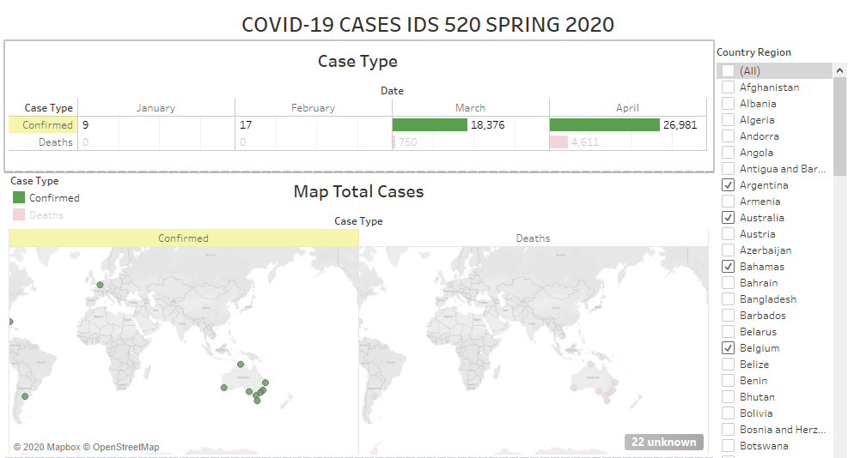

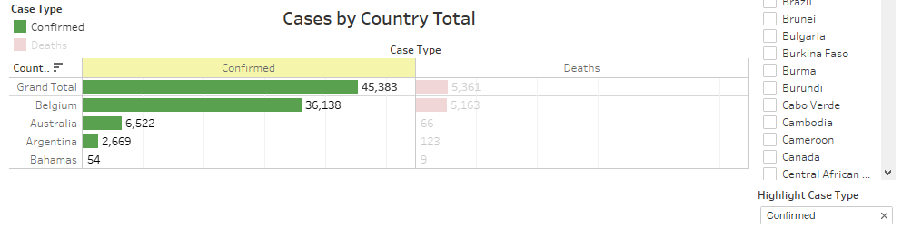

Deaths case type:

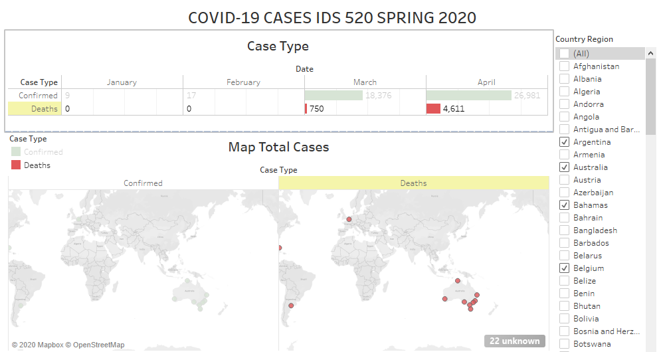

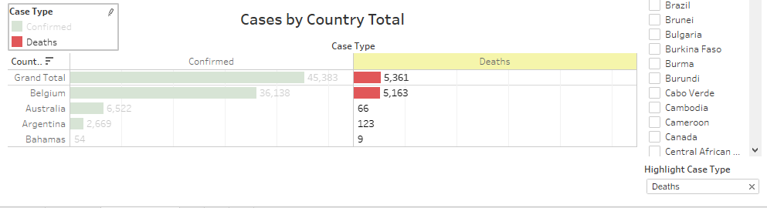

**COUNTRY-WISE COVID-19 CASES**

